EXP.NO: 07 | IPC using Shared Memory

AIM:

To implement a C program that facilitates communication between two independent processes (a Sender and a Receiver) using System V Shared Memory. The objective is to allow the Sender to write a string into a shared memory segment and the Receiver to read and display that same string.

ALGORITHM:

1. Identify the Segment
Both processes define a unique Key (e.g., 1234). This acts as a common ID so they can find the same memory location.

2. Create / Access (shmget)
The Sender creates a 1024-byte memory segment using shmget with the IPC_CREAT flag.
The Receiver uses the same key to locate the existing segment.

3. Attach to Address Space (shmat)
Both processes "map" the shared memory into their own memory space. This returns a pointer (str), allowing them to interact with the shared memory as if it were a local variable.

4. Data Exchange
Sender: Takes user input via scanf and writes it to the memory pointed to by str.
Receiver: Reads the string directly from the same pointer str and prints it.

5. Detach (shmdt)
The Receiver detaches from the memory segment once the reading is complete to ensure clean termination.

CODE:

// sender
#include <stdio.h>
#include <sys/ipc.h>
#include <sys/shm.h>
#include <string.h>

int main() {
key_t key = 1234;
int shmid;

shmid = shmget(key, 1024, 0666 | IPC_CREAT);

char *str = (char*) shmat(shmid, (void*)0, 0);

printf("Enter message: ");
scanf(" %[^\n]", str);

printf("Data written to shared memory: %s\n", str);

return 0;
}

//receiver

#include <stdio.h>
#include <sys/ipc.h>
#include <sys/shm.h>

int main() {
key_t key = 1234;
int shmid;

shmid = shmget(key, 1024, 0666);

char *str = (char*) shmat(shmid, (void*)0, 0);

printf("Data read from shared memory: %s\n", str);

shmdt(str);

return 0;
}

OUTPUT:

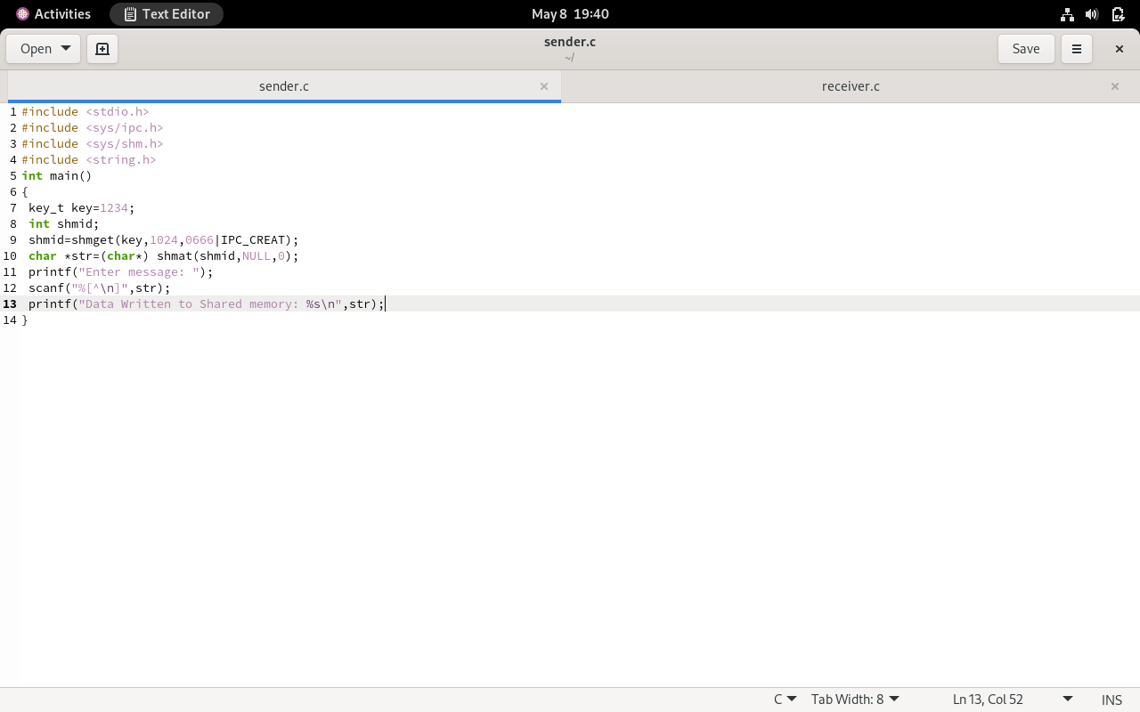
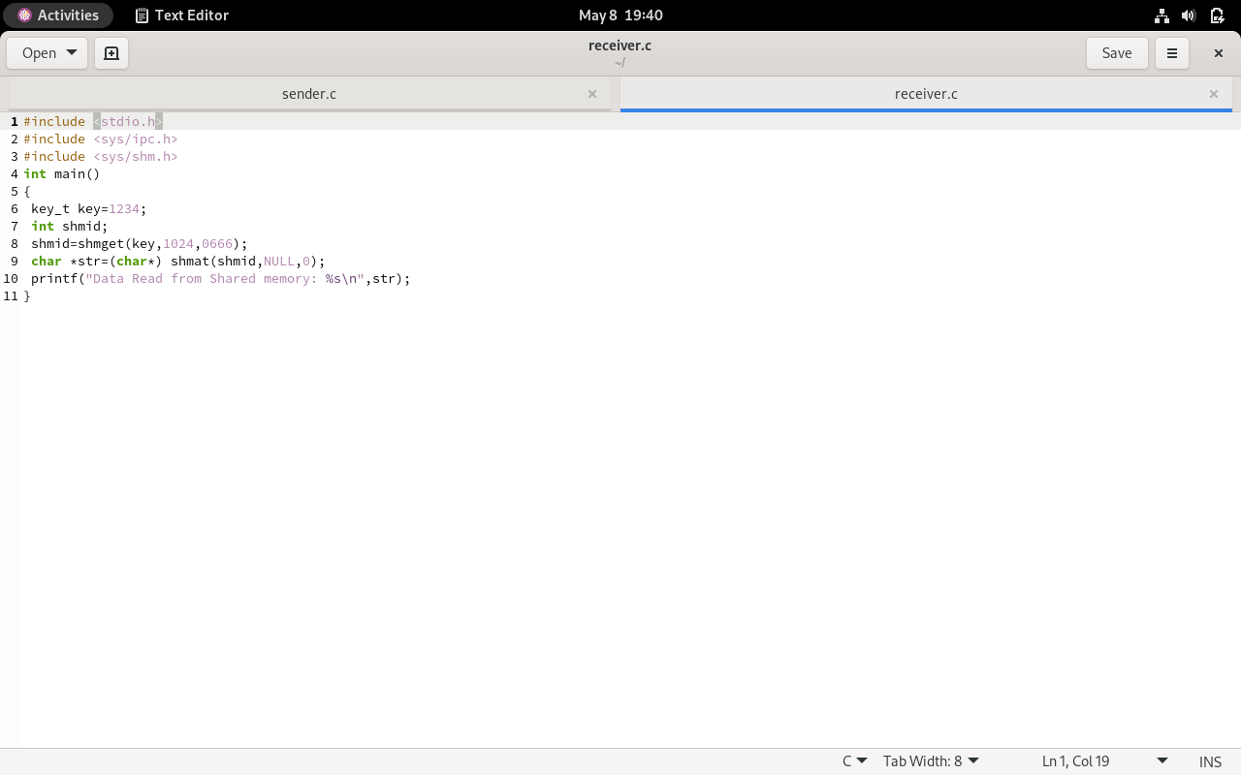

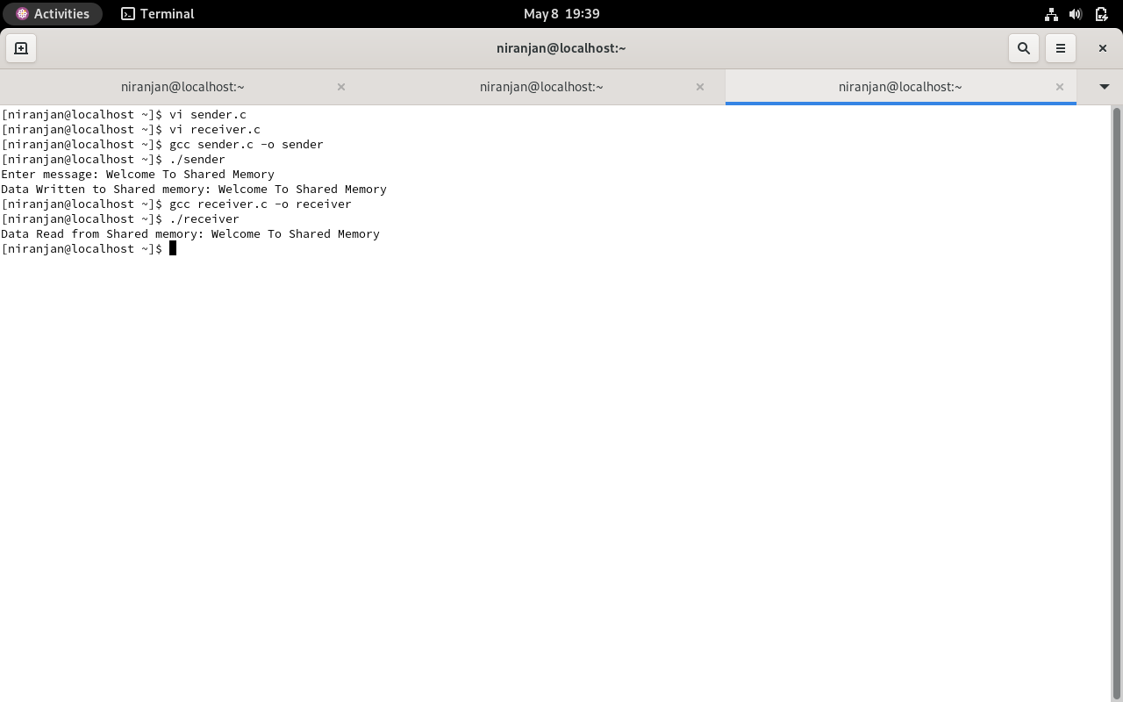
RESLT:
The shared memory communication between two processes was successfully implemented using Inter-Process Communication (IPC). The sender process wrote data into the shared memory segment, and the receiver process successfully accessed and displayed the same data from shared memory.
.

